ping (Packet Internet Groper) is used to test connectivity between two devices by sending ICMP (Internet Control Message Protocol) Echo Request packets.
ping <ip address>

OUTPUT
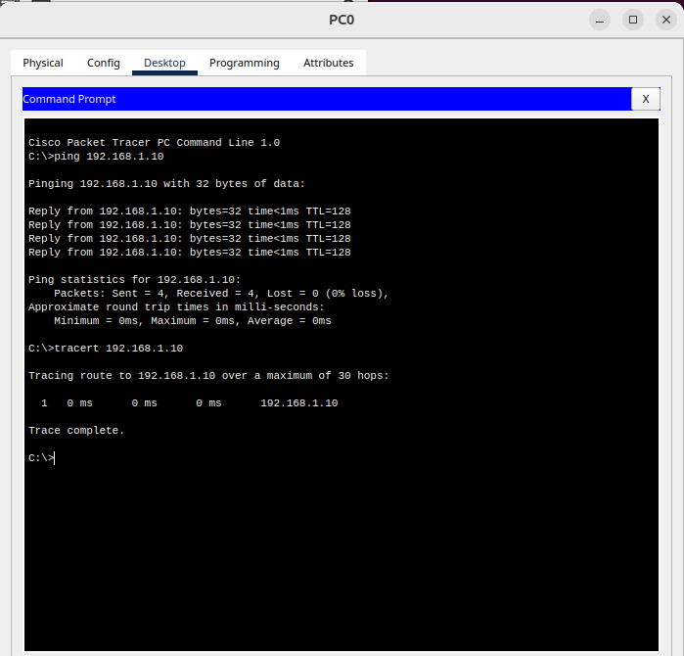

Reply from 192.168.1.18: bytes=32 time=2ms TTL=64

Bytes: Data sent (default 32 bytes).
Time: Response time in milliseconds.
TTL (Time to Live): Maximum hops before packet is discarded.

Failure Case:
Request timed out.
Possible reasons:
- Destination is unreachable.
- Network issue.
- Firewall blocking ICMP packets.
OPTIONS IN PING COMMAND :

- ping <host/ip> (continuously pings until ctrl+C)
- ping -c 5 <host/ip> (sends only 5 packets and analyses)
- ping -s <pkt size> <host/ip> (to change the icmp echo packet size)
- ping -6 <host/ip> (to use ipv6)
- sudo ping -f <host/ip> (used for diagnosis purposes – creates ping flood)
- ping -w <time in seconds> <host/ip> (total duration to ping)
- ping -q <host/ip> (quiet output – releases only summary of pinging)
- ping -i <host/ip> (Set interval between ping packets (default: 1 sec))

TRACEROUTE

traceroute shows the path that packets take from the source to the destination, identifying each router (hop) along the way.

traceroute <destination_IP>

Ping is just used to whether the destination IP is reachable or not, but traceroute can be used to track the exact path travelled by a packet. It helps in finding the network delays and failure

OPTIONS IN TRACEROUTE COMMAND :

- traceroute <host/ip> (for max. of 30 hops, it tries to find out the path of destination IP)
- traceroute -n <host/ip> (don’t resolve IP addresses – for faster execution)
- traceroute -I <host/ip> (use icmp packets and not udp)
- traceroute -T <host/ip> (uses tcp packets for traceroute to avoid icmp/udp block in intermediate firewall)
- traceroute -m <#hops> <host/ip> (limits max. number of hops)
- traceroute -w <count> <host/ip> (set timeout per hop in seconds)

